Ester Notes

Esters
- Esters make up a lot of smells in products such as fruit, perfumes, glue, nail polish remover.
- They are made with a Carboxylic Acid + Alcohol
  - OH of Carboxylic acid + Alcohol
  - Process is called esterification (reversible)
- RCOOR’


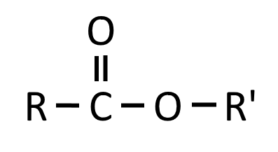
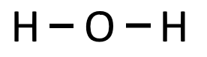


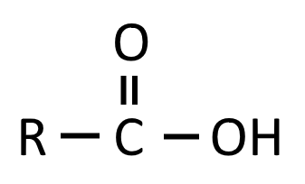



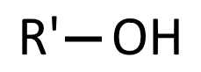
Naming
- Name of Alkyl group bonded to single bonded O (R’)
- Name of Carboxylic Acid, ending replaced with “oate” (RCOO)
- Normally you would read it “backwards”

1. Ethyl 2. Ethanoic acid ⟹ Ethanoate
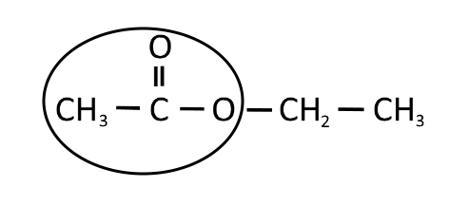
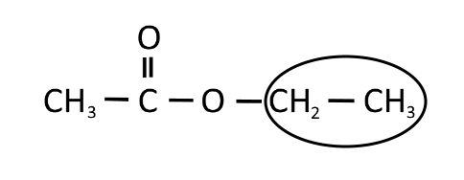
3. Ethyl Ethanoate

